##™
Yahtzee XP is a quick and easy way to have fun on you’re home or office computer!!

Welcome to Yahtzee XP, the Yahtzee XP is the Windows XP version of the Yahtzee Dice game.

Below are some popular Help topics:
- Yahtzee Game Rules
- Yahtzee Game Strategies
- Quickstart
- End User License Agreement

Yahtzee XP© Salex Software©, DigiScene Studios© 2002-2003
Alex Smoljanovic

kk##Yahtzee Game Rules

Each turn consists of up to three rolls of five dice. After the first roll, you have the option of keeping any number of dice by holding dice. The set of dice you have left after the last go is the set you will be scoring on.

Turns are repeated until all score boxes are used. Each score box can only be used once. If the hand shown does not match the score method you chose, you will get a score of zero for that score box.

Ones - Sixes
Score: Sum of all dice with the named value. (i.e. If you have [4, 6, 3, 4, 4] as your 5 dice, and place it in the 4's, you will score 12 points (4x3), if you place it in the 5's you will score 0, and if you place it in 6's, you will score 6). If sum of Ones through Sixes is greater than or equal to 63 a bonus of 35 points will be awarded.

3 of a Kind
Score: Sum of all dice if 3 dice with the same value are in the hand.

4 of a Kind
Score: Sum of all dice if 4 dice with the same value are in the hand.

Full House
Score: 25 points if the hand contains two of one value and three of another. Yahtzee can also be placed in here (see Yahtzee! section for details).

Low Straight
Score: 30 points if a sequence of 4 is in the hand (e.g. {1, 2, 3, 4}, {2, 3, 4, 5} or {3, 4, 5, 6} not necessarily in that order). Yahtzee can also be placed in here (see Yahtzee! section for details).

High Straight
Score: 40 points if a sequence of 5 is in the hand (e.g. {1, 2, 3, 4, 5}, or {2, 3, 4, 5, 6}, not necessarily in that order). Yahtzee can also be placed in here (see Yahtzee! section for details).

Yahtzee!
Score: 50 points for first 5 of a kind, and 100 points for each one thereafter. When you get a Yahtzee, you have a choice of where to place it. Obviously, if the Yahtzee section is not filled, that is the best place for it, but after that is filled in AND the corresponding number of the Yahtzee (ie. A throw of all 4's would be the 4 section) is also filled in, you can place it in Full House, Low Straight or High Straight. For example, you get a throw of {5, 5, 5, 5, 5}, and you have already had a yahtzee. If the 5's section is not filled in, you can place it in there for a score of 25. You can also place it in 3 or 4 of a kind (also for a score of 25). However, if the 5's ARE filled in, you can choose not only to place it in 3 or 4 of a kind, but also Full House and Low or High Straight (25, 30 and 40 points respectively). It's one of those tricky rules not many people know about, but summed up, if you get a subsequent yahtzee and the corresponding number is filled in, it becomes a Joker and can be placed in the above sections.

Chance
Score: Sum of all dice in hand. This is used when you have a bad hand that can't be placed anywhere.
##To Hold a dice, click either the dice or the ‘Hold’ button below the dice.
To un-hold a dice, click either the dice or the ‘Held’ button below the dice once again.
kk##Yahtzee Game Strategies

In order to constantly achieve high scores, you need to adopt certain Tactics, some of which are:

° Try not to use your 'chance' up too quick. When you do use it, go for the highest total possible.
° Always go for the bonus in the 1's to 6's section. Remember, you need 63 or over to get the 35 point bonus. (63 is calculated from an average of 3 of each type, ie. 3x1's, 3x2's, etc.)
° When you go for 3 and 4 of a kind, always go for high numbers, as these form the basis for your total.
° If you have a bad throw, and have nowhere to place it, think about putting it in Yahtzee or 1's. 1's always scores low, and Yahtzee is rare to come by!

One other strategy which seems to work pretty well most times is the ‘Yahtzee Strategy’. This is where you literally try to use every score box for a Yahtzee as yahtzee’s are worth the most.

If you are able to use the Full house, Low and High Straight first before every other score box with the exception of maybe the One’s and Two’s, you have a far greater chance of not only acquiring the 35 point bonus but one or more yahtzee’s as well.

First off, try to ‘make’ you’re hand a full house, say you’re draw is two 2’s, and two 4’s, well you have a better chance of getting one more 2’s or 4’s since there are only six faces on a dice, so the odds of getting you’re full house are 1 in 3. Also if you fail to get the full house well you still have the option of using one of the One’s through Six’s score boxes. Since you would only have two of the same dice, place it in the lowest of the two which in this case would be Two’s.

If you feel you have a better chance for something else, go for it. But if you are able to use the Full House, Low and High Straight first then you will be able to try to get a yahtzee on every other score box.

Now, say that you have used the Full House, Low and High Straight score boxes, then you’re next goal is to acquire as many of the same dice values as you can. For instance say on you’re next first draw you’re hand is composed of two 2’s, one 3,4, and 5. Well since you’re One’s through Six’s should all be empty and so should you’re three and four of a kind score boxes then you should be holding you’re 2’s, try to get as many twos as you possibly can, then put them in the Two’s score box. Say you get four 2’s, and you’re three and four of a kind score boxes are still empty, don’t use them unless you have to because 2’s are a low dice.

Go right through the One’s through Six’s(The order in which you do them is dependant on you’re draws), once you get to Four, Fives or Six’s start considering to use them as Three or Four of a kindS.

So you see, if you can use the score boxes which don’t require as many of the same dice as possible, then you have 10 chances to get a Yahtzee. And by doing this you’re chances of getting the 35 point bonus also increase because you are not using the One’s through Six’s score boxes as ‘fall backs’. If you’re sum of One’s through Six’s is greater than or equal to 63 you are awarded with an additional 35 point bonus.

Also by using this tactic it is possible to receive one or more 100 point bonuses for getting two or more Yahtzee’s.

Playing Yahtzee using these general rules resulted in the following:

One’s: 4
Two’s: 6
Three’s: 9
Four’s: 12
Five’s: 20
Six’s: 24
Three of a kind: 19
Four of a kind: 31
Full House: 25
Low Straight: 30
High Straight: 40
Yahtzee: 50
Chance: 25
Bonus: 135
Total: 430

Playing Yahtzee using other general rules resulted in the following:

One’s: 1
Two’s: 4
Three’s: 0
Four’s: 8
Five’s: 15
Six’s: 6
Three of a kind: 14
Four of a kind: 19
Full House: 25
Low Straight: 30
High Straight: 40
Yahtzee: 0
Chance: 13
Bonus: 0
Total: 175

Using these rules will not guarantee you a high score every time, but you have a far greater chance of getting a high score simply because you will most likely get that 35 point bonus plus at least one Yahtzee(usually).

For more Yahtzee Game related info see: Game Rules
kk##Quick Start Yahtzee XP

Once you open Yahtzee XP you are already set to start playing a one player game, if you wish to add one or more players do so by using the Players menu to access the Add and Remove Player Dialog. After you add or remove a player you game is reset once again.

Once you are ready to start the game, simply roll the dice by clicking the Roll Dice button.

For more useful information while in game play look at the status label in between the Clear Holds and Stand button located directly under the dice. It will keep you updated on the games current status.

To restart the game at any time, click the ‘New Game’ sub-menu item in the ‘File’ menu. Or press Ctrl+N.
kk##High Scores

To add a high score you must first achieve a score which is greater than the 10th highest score, or equal to at least the 9th.
To view the High Scores at any time, press Ctrl+H on you’re keyboard. Or click the sub-menu item ‘High Scores’ in the ‘File’ menu.

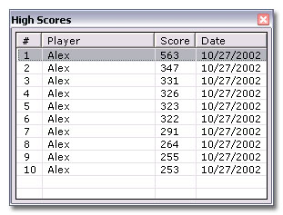

For more information on scoring see: Yahtzee Game Rules
kk##Options

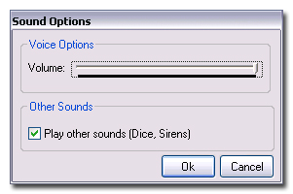

This Sound Options dialog allows you to adjust the volume of the narrator’s voice and also gives you the option of playing other sounds such as the rolling dice sound, Yahtzee Siren, and Holding sounds.
kk##Players

To view this dialog, either press Ctrl+Insert, or access it through the menu ‘Players’.
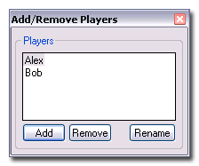

To add a player to the game, click the add button. You will then be prompted for the new player’s name.
To remove a player select the players name in the list, and click the ‘Remove’ button.
To rename an existing player, select the player’s name you wish to change and click the ‘Rename’ button.

Warning: By adding or removing a player to the game certain game variables change and so the game must be reset. While you are attempting to add or remove a player you will be asked if you wish to restart the current game.

Multiplayer games:

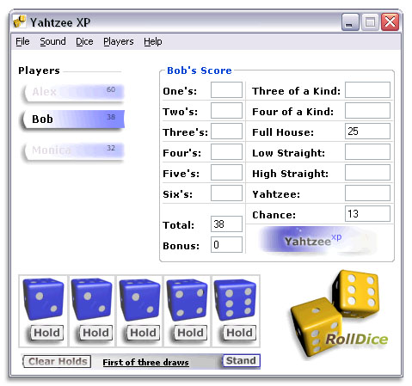
When a game is played with more than one player, you can determine who’s turn it is by which player is Highlighted. Notice to the left of the Score Card (“Bob’s Score”) there are three symbols representing three players, all of which are named and have a small number to the upper-right. The small number represents that players score.

There is a maximum of 6 players per game.

Return to Index topic
kk##Loading and Saving Games

For you’re convenience Yahtzee XP gives you the ability to save and load games.

To save you’re current game press Ctrl+S, or click the ‘Save’ menu under the ‘File’ menu.
To load a previous game press Ctrl+O, or click the ‘Load’ menu under the ‘File’ menu.
kk##About

Yahtzee XP is the Windows XP version of the Yahtzee Dice game.

Yahtzee XP is 32-bit Yahtzee program which uses the Learnout and Hauspie TruVoice speech synthesization engine produced by Microsoft.
Yahtzee XP is designed specifically for 64-bit Windows NT 5.1 (Windows XP)

If you wish to contact Salex Software please do so via electronic mail to the address salex_software@shaw.ca


Yahtzee XP© Salex Software© 2003, DigiScene Studios© 2003
The about images are registered Trademarks of the Salex Software Corporation, or DigiScene Studios Company

Related topics: End-User-License-Agreement (EULA)
##By pressing the ‘Clear Holds’ button you are clearing the Holding status of all the dice.
##By pressing the ‘Stand’ button you are forfeiting the rest of you’re draws and keeping all the dice in you’re hand.
kk## End User License Agreement

™ Salex Software© 2002-2003, DigiScene Studios© 2002-2003

This program is Freeware. That means that it is completely free to use. There is no upgrade charge to receive new versions, this is the FULL version, free and ready for you to use!

You may make as many copies of this software and documentation as you wish; give exact copies of the original version to anyone; and distribute the game and documentation in its unmodified form via electronic means. There is no charge for any of the above.

You are specifically prohibited from charging, or requesting donations, for any such copies, however made; and from distributing the software and/or documentation with other products (commercial or otherwise) without prior written permission (via email), with one exception: Disk Vendors approved by the Association of Shareware Professionals are permitted to redistribute this version of Yahtzee XP distributed with this Help File subject to the above conditions, without specific written permission.

You are prohibited from using any images used by this application for any purpose unless you are given written permission by the author of such images. Warning, each and every image is embedded with a ‘Watermark’ containing copyright information.

Disclaimer
THIS SOFTWARE AND THE ACCOMPANYING FILES ARE SOLD "AS IS" AND WITHOUT WARRANTIES AS TO PERFORMANCE OF MERCHANTABILITY OR ANY OTHER WARRANTIES WHETHER EXPRESSED OR IMPLIED.

Related topics: About Yahtzee XP

k One’s;Two’s;Three’s;Four’s;Five’s;Six’s;Three of a kind;Four of a Kind;Full House;Low Straight;High Straight;Yahtzee;Chance;scoring
# popHold
k tactics;strategy
# tpcStrat
k restarting;starting a game
# tpcQuickStart
k high scores
# tpcHighScores
k sounds;options;voice;
# tpcOptions
k players;adding players;removing players
# tpcPlayers
k saving games;loading games
# tpcLoadSave
k contact salex software;about Yahtzee XP
# tpcAbout
# popClearHolds
# popStand
k disclaimer;program rights
#tpcEULA
# tpcDefault
# tpcRules

